**Assignment 2: Question 1**

In the table below, the xi column Drilling Depth. Similarly, the yi column Minimum Pressure.

xi – x(mean) and yi – y(mean) shows the deviation scores

Last two rows show sums and mean scores that we will use to conduct the regression analysis.

|  |  |  |  |  |  |
| --- | --- | --- | --- | --- | --- |
|  | **Drilling Depth(mm) (x)** | **Minimum Pressure [MPa] (y)** | **xi - x(mean)** | **yi-y(mean)** | **(xi - (mean)  * yi -y(mean)** |
| 1 | 0.5 | 79.4 | -2 | 26.8855556 | -53.7711 |
| 2 | 1 | 46.33 | -1.5 | -6.1844444 | 9.276667 |
| 3 | 1.5 | 44.33 | -1 | -8.1844444 | 8.184444 |
| 4 | 2 | 44.85 | -0.5 | -7.6644444 | 3.832222 |
| 5 | 2.5 | 48.54 | 0 | -3.9744444 | 0 |
| 6 | 3 | 49.64 | 0.5 | -2.8744444 | -1.43722 |
| 7 | 3.5 | 52.44 | 1 | -0.0744444 | -0.07444 |
| 8 | 4 | 53 | 1.5 | 0.48555556 | 0.728333 |
| 9 | 4.5 | 54.1 | 2 | 1.58555556 | 3.171111 |
| Sum | 22.5 | 472.63 | 0 |  | -30.09 |
| Mean | 2.5 | **52.51444444** |  |  |  |
|  | x(mean) = 2.5 | y(mean) = 52.514 |  |  |  |

xi-x(mean)2 is the squares of the deviation score for Drilling depth

yi – y(mean)2 is the squared of the deviation score for Minimum pressure

|  |  |  |  |  |
| --- | --- | --- | --- | --- |
|  | **Drilling Depth(mm) (xi)** | **Minimum Pressure [MPa] (yi)** | **(xi-x(mean))2** | **(yi-y (mean))2** |
| 1 | 0.5 | 79.4 | 4 | 722.6837335 |
| 2 | 1 | 46.33 | 2.25 | 38.21986666 |
| 3 | 1.5 | 44.33 | 1 | 66.98149333 |
| 4 | 2 | 44.85 | 0.25 | 58.74030222 |
| 5 | 2.5 | 48.54 | 0 | 15.79444222 |
| 6 | 3 | 49.64 | 0.25 | 8.249655554 |
| 7 | 3.5 | 52.44 | 1 | 0.005508889 |
| 8 | 4 | 53 | 2.25 | 0.235494445 |
| 9 | 4.5 | 54.1 | 4 | 2.513105556 |
| Sum | 22.5 | 472.63 | 15 | 913.4236023 |
| Mean | **2.5** | **52.51444444** |  |  |

The regression equation is a linear equation of the form: ŷ = b0 + b1x . To conduct a regression analysis, we need to solve for b0 and b1.

Notice that all of our inputs for the regression analysis come from the above three tables.

First, we solve for the regression coefficient (b1):

b1 = Σ [ (xi – x(mean))(yi – y(mean)) ] / Σ [ (xi – x(mean))2]

b1 = -30.09/ 15

b1 = - 2.006

Once we know the value of the regression coefficient (b1), we can solve for the regression slope (b0):

b0 = y(mean) - b1 * x(mean)

b0 = 52.14 – (-2.006) * 2.5

b0 = 52.514 + 5.015 = 57.529

Therefore, the regression equation is: ŷ = 57.529 -2.006 x .

|  |  |
| --- | --- |
| b1 | -2.006 |
| b0 | -57.529 |

|  |  |  |  |  |
| --- | --- | --- | --- | --- |
|  | Loss Function |  |  |  |
|  | xi | y(Predicted) | Y (true) Given | y(Predicted) - y i(given) |
| 1 | 0.5 | 56.522 | 79.4 | -22.878 |
| 2 | 1 | 55.519 | 46.33 | 9.189 |
| 3 | 1.5 | 54.516 | 44.33 | 10.186 |
| 4 | 2 | 53.513 | 44.85 | 8.663 |
| 5 | 2.5 | 52.51 | 48.54 | 3.97 |
| 6 | 3 | 51.507 | 49.64 | 1.867 |
| 7 | 3.5 | 50.504 | 52.44 | -1.936 |
| 8 | 4 | 49.501 | 53 | -3.499 |
| 9 | 4.5 | 48.498 | 54.1 | -5.602 |
|  |  |  |  | 9.061 |

Loss function as mean squared error is 4.56

How well the equation fits the data?

The way to assess fit is to check the [coefficient of determination](https://stattrek.com/Help/Glossary.aspx?Target=Coefficient%20of%20determination), which can be computed from the following formula.

R2 = { ( 1 / N ) * Σ [ (xi – x(mean)) * (yi – y(mean)) ] / (σx * σy ) }2

standard deviation of x (σx):

σx = sqrt [ Σ ( xi – x(mean) )2 / N ]

= sqrt(15/9) = 1.29

standard deviation of y, (σy):

σy = sqrt [ Σ ( yi - y (mean))2 / N ]

= sqrt(913.523/9) = 10.074

R2 = squared (1/9 * (- 30.09) / (1.29*10.074)) = squared(30.09/116.91) = 0.25

A coefficient of determination equal to 0.25 indicates that about 25% of the variation

Method for finding the value by minimizing the error function by finding the stationary point of error is as follows

Part (b)

The minimum pressure that will be at 3.8mm depth is as follows

ŷ = 57.529 -2.006 (3.8) = 57.529 – 7.62 = 49.909 MPa

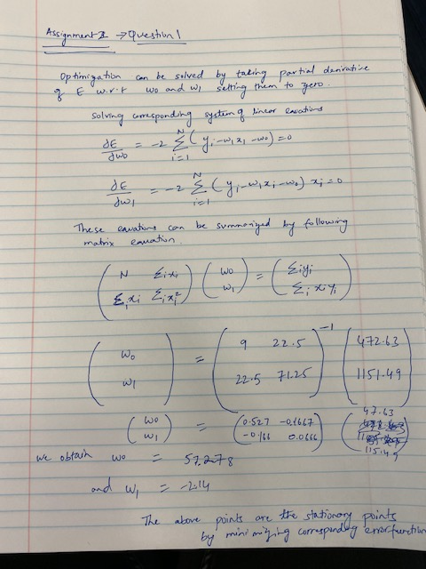

Question 2

|  |  |
| --- | --- |
| **Assignment 2: Question 2** |  |
| **Please see the part of the solution to the part below** | **Python solution is available in the juniper notebook** |

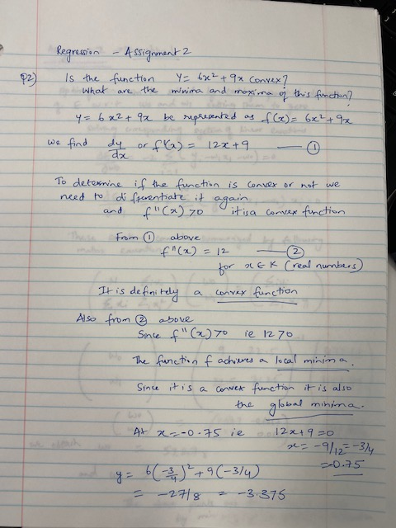

|  |  |
| --- | --- |
| **Assignment 2: Question 3** | **Solution using Gradient Descent Algorithm** |
| **w0 is 0 so the equation is of the form y = w1(x)** | **y=(w1)x is line passing through origin** |
| **Let’s choose a value for w1 as 1.75** |  |

**Iterations 1 through 8 showcase Gradient Descent Algorithm and converge of Error Term towards 0 that is the minima of the function.**

|  |  |  |  |  |  |
| --- | --- | --- | --- | --- | --- |
| **Iteration 1** | **y=w1(x)** | **1.75** |  |  |  |
| **x** | **y** | **ypredicted** | **ypredicted - y** | **sq(ypred-y)** | **dow (E)/dow(w1)** |
| **1** | **0.5** | **1.75** | **1.25** | **1.5625** | **1.25** |
| **2** | **1** | **3.5** | **2.5** | **6.25** | **5** |
| **4** | **2** | **7** | **5** | **25** | **20** |
| **0** | **0** | **0** | **0** | **0** | **0** |
|  |  |  | **Error Term** | **32.8125** | **26.25** |
|  |  |  |  |  |  |
| **Note1: The Error Term first calculated is 32.8125 Note2: The first derivative of error function is 26.25** |  |  |  |  |  |

|  |  |  |  |  |  |
| --- | --- | --- | --- | --- | --- |
| **Iteration 2** | **y=w1(x)** |  |  |  |  |
| **Let the ETA Rate 0.01** |  |  |  |  |  |
| **New w1 =** | **Oldw1 - EtaRate *dow(E)/dow(w1)** | | |  |  |
| **w1** | **1.75 - 0.01 * 26.25** | **1.4875** |  |  |  |
|  | **w1=** | **1.49** |  |  |  |
| **x** | **y** | **ypredicted** | **ypredicted - y** | **sq(ypred-y)** | **dow(E)/dow(w1)** |
| **1** | **0.5** | **1.49** | **0.99** | **0.9801** | **0.99** |
| **2** | **1** | **2.98** | **1.98** | **3.9204** | **3.96** |
| **4** | **2** | **5.96** | **3.96** | **15.6816** | **15.84** |
| **0** | **0** | **0** | **0** | **0** | **0** |
|  |  |  | **Error Term** | **20.5821** | **20.79** |
|  |  |  |  |  |  |

Take Notice1: For Iteration 2 the Error Term reduced from 32.8125 to 20.5821

Take Notice2: For Iteration 2 the first derivative of error functon reduced from 26.25 to 20.79

|  |  |  |  |  |  |
| --- | --- | --- | --- | --- | --- |
| **Iteration 3** | **y=w1(x)** |  |  |  |  |
| **Let the ETA Rate 0.01** |  |  |  |  |  |
| **New w1 =** | **Oldw1 - EtaRate *dow(E)/dow(w1)** | |  |  |  |
| **w1** | **1.49 - 0.01 * 20.79** | **1.2821** |  |  |  |
|  |  | **1.28** |  |  |  |
| **x** | **y** | **ypredicted** | **ypredicted - y** | **sq(ypred-y)** | **dow (E)/dow(w1)** |
| **1** | **0.5** | **1.28** | **0.78** | **0.6084** | **0.78** |
| **2** | **1** | **2.56** | **1.56** | **2.4336** | **3.12** |
| **4** | **2** | **5.12** | **3.12** | **9.7344** | **12.48** |
| **0** | **0** | **0** | **0** | **0** | **0** |
|  |  |  | **Error Term** | **12.7764** | **16.38** |

Take Notice1: For Iteration 2 the Error Term reduced from 20.5821 to 12.7764

Take Notice2: For Iteration 2 the first derivative of error functon reduced from 20.79 to 16.38

|  |  |  |  |  |  |
| --- | --- | --- | --- | --- | --- |
| **Iteration 4** | **y=w1(x)** |  |  |  |  |
| **Let the ETA Rate 0.01** |  |  |  |  |  |
| **New w1 =** | **Oldw1 - EtaRate *dow(E)/dow(w1)** | | |  |  |
| **w1** | **1.28 - 0.01 * 16.38** | **1.1162** |  |  |  |
|  |  | **1.1** |  |  |  |
| **x** | **y** | **ypredicted** | **ypredicted - y** | **sq(ypred-y)** | **dow(E)/dow(w1)** |
| **1** | **0.5** | **1.1** | **0.6** | **0.36** | **0.6** |
| **2** | **1** | **2.2** | **1.2** | **1.44** | **2.4** |
| **4** | **2** | **4.4** | **2.4** | **5.76** | **9.6** |
| **0** | **0** | **0** | **0** | **0** | **0** |
|  |  |  | **Error Term =** | **7.56** | **12.6** |

Take Notice1: For Iteration 2 the Error Term reduced from 12.7764 to 7.56

Take Notice2: For Iteration 2 the first derivative of error functon reduced from 16.38 to 12.6

|  |  |  |  |  |  |
| --- | --- | --- | --- | --- | --- |
| **Iteration 5** | **y=w1(x)** |  |  |  |  |
| **Let the ETA Rate 0.01** |  |  |  |  |  |
| **New w1 =** | **Oldw1 - EtaRate *dow(E)/dow(w1)** | | |  |  |
| **w1** | **1.1 - 0.01 * 12.6** | **0.974** |  |  |  |
|  |  | **0.9** |  |  |  |
| **x** | **y** | **ypredicted** | **ypredicted - y** | **sq(ypred-y)** | **dow(E)/dow(w1)** |
| **1** | **0.5** | **0.9** | **0.4** | **0.16** | **0.4** |
| **2** | **1** | **1.8** | **0.8** | **0.64** | **1.6** |
| **4** | **2** | **3.6** | **1.6** | **2.56** | **6.4** |
| **0** | **0** | **0** | **0** | **0** | **0** |
|  |  |  | **Error Term =** | **3.36** | **8.4** |

Take Notice1: For Iteration 2 the Error Term reduced from 7.56 to 3.36

Take Notice2: For Iteration 2 the first derivative of error functon reduced from 12.6 to 8.4

|  |  |  |  |  |  |
| --- | --- | --- | --- | --- | --- |
| **Iteration 6** | **y=w1(x)** |  |  |  |  |
| **Let the ETA Rate 0.01** |  |  |  |  |  |
| **New w1 =** | **Oldw1 - EtaRate *dow(E)/dow(w1)** | | |  |  |
| **w1** | **0.9 - 0.01 * 8.4** | **0.816** |  |  |  |
|  |  | **0.8** |  |  |  |
| **x** | **y** | **ypredicted** | **ypredicted - y** | **sq(ypred-y)** | **dow (E)/dow(w1)** |
| **1** | **0.5** | **0.8** | **0.3** | **0.09** | **0.3** |
| **2** | **1** | **1.6** | **0.6** | **0.36** | **1.2** |
| **4** | **2** | **3.2** | **1.2** | **1.44** | **4.8** |
| **0** | **0** | **0** | **0** | **0** | **0** |
|  |  |  | **Error Term =** | **1.89** | **6.3** |

Take Notice1: For Iteration 2 the Error Term reduced from 3.36 to 1.89

Take Notice2: For Iteration 2 the first derivative of error functon reduced from 8.4 to 6.3

|  |  |  |  |  |  |
| --- | --- | --- | --- | --- | --- |
| **Iteration 7** | **y=w1(x)** |  |  |  |  |
| **Let the ETA Rate 0.01** |  |  |  |  |  |
| **New w1 =** | **Oldw1 - EtaRate *dow(E)/dow(w1)** | | |  |  |
| **w1** | **0.8 - 0.01 * 6.3** | **0.737** |  |  |  |
|  |  | **0.7** |  |  |  |
| **x** | **y** | **ypredicted** | **ypredicted - y** | **sq(ypred-y)** | **dow(E)/dow(w1)** |
| **1** | **0.5** | **0.7** | **0.2** | **0.04** | **0.2** |
| **2** | **1** | **1.4** | **0.4** | **0.16** | **0.8** |
| **4** | **2** | **2.8** | **0.8** | **0.64** | **3.2** |
| **0** | **0** | **0** | **0** | **0** | **0** |
|  |  |  | **Error Term =** | **0.84** | **4.2** |

Take Notice1: For Iteration 2 the Error Term reduced from 1.89 to 0.84

Take Notice2: For Iteration 2 the first derivative of error functon reduced from 6.3 to 4.2

|  |  |  |  |  |  |
| --- | --- | --- | --- | --- | --- |
| **Iteration 8** | **y=w1(x)** |  |  |  |  |
| **Let the ETA Rate 0.01** |  |  |  |  |  |
| **New w1 =** | **Oldw1 - EtaRate *dow(E)/dow(w1)** | | |  |  |
| **w1** | **0.7 - 0.01 * 4.2** | **0.658** |  |  |  |
|  |  | **0.6** |  |  |  |
| **x** | **y** | **ypredicted** | **ypredicted - y** | **sq(ypred-y)** | **dow(E)/dow(w1)** |
| **1** | **0.5** | **0.6** | **0.1** | **0.01** | **0.1** |
| **2** | **1** | **1.2** | **0.2** | **0.04** | **0.4** |
| **4** | **2** | **2.4** | **0.4** | **0.16** | **1.6** |
| **0** | **0** | **0** | **0** | **0** | **0** |
|  |  |  | **Error Term =** | **0.21** | **2.1** |

Take Notice1: For Iteration 2 the Error Term reduced from 0.84 to 0.21

Take Notice2: For Iteration 2 the first derivative of error functon reduced from 4.2 to 2.1